Module (CSS and CSS 3) -2

1. What are the benefits of using CSS?

=> Better website speed: CSS can help to improve the speed of your website by reducing the amount of code that needs to be downloaded

Easier to maintain: CSS is a separate language from HTML, which means that it can be easily maintained and updated.

Consistent design: CSS can be used to create a consistent design across your website

More formatting options: CSS offers a wide range of formatting options, which means that you can create a truly unique and visually appealing website

Device compatibility: CSS is supported by all major browsers, so your website will look good on any device.

1. What are the disadvantages of CSS?

=> Complexity: CSS can be a complex language, and it can take some time to learn how to use it effectively.

Browser compatibility: CSS is not always compatible with all browsers, which can lead to problems with the appearance of your website.

Security: CSS can be vulnerable to security attacks, which can be used to steal data or inject malicious code into your website.

Performance: CSS can add to the size of your website, which can slow down the loading time.

1. What is the difference between CSS2 and CSS3?

=>

|  |  |  |
| --- | --- | --- |
|  | CSS | CSS3 |
| Media Queries | Doesn’t support | Supports responsive web design |
| Browser Support | No support for modern browsers, but it still works on older versions of Explorer or Chrome | Supported fully by all modern browsers |
| Block Support | Supports single blocks only | Supports multi-column text blocks |
| Animation Use | It only allows basic animations and doesn't support transformation, text animation, transition, or 3D animations | It offers advanced animations and many customization options. It also supports text animation, transformation, and transition |
| Responsive Design | It doesn’t support media queries, thus not ideal for making responsive designs | Works with media queries, thus allowing responsive web design |
| Color Format | It uses an old standard color format | It offers different gradient colors and schemes like RGBA, HSLA, HSL, etc. |

1. Name a few CSS style components

=> color= set the color of text.

font-size=size of text.

background-color=background color of an element

width/height=width of an elements

margin=space of outside of an elements

padding=space of inside of an elements

border=border around an element

text-align=text-align use text center

1. What do you understand by CSS opacity?

=> opacity is a property that controls the transparency of an element.

In CSS, opacity is a property that controls the transparency of an element. The opacity property can be used to make an element partially transparent, or even completely transparent.

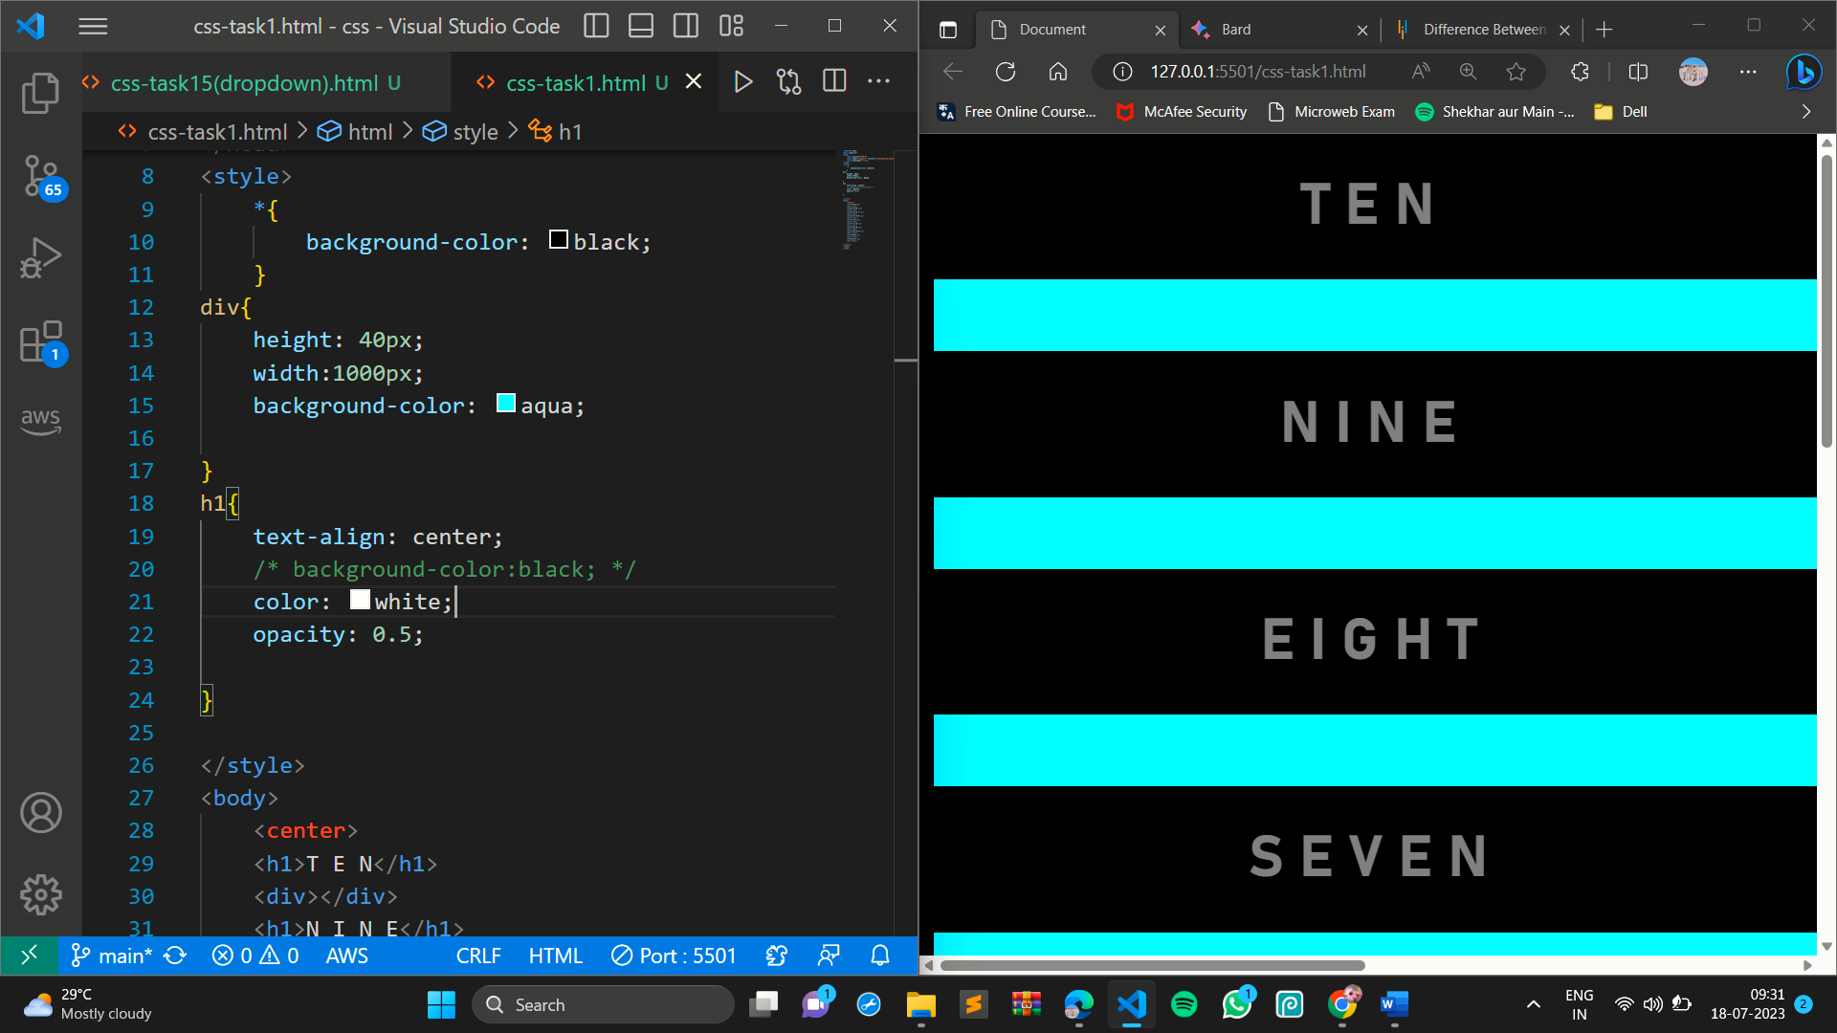

The opacity property is a number between 0 and 1, where 0 is completely transparent and 1 is completely opaque.

1. How can the background color of an element be changed?

=> The background color of an element can be changed using the background-color property in CSS.

The background-color property can be set to a variety of values:- color name (red), Hex codes(#FF0000), RGB values, RGBA values

1. How can image repetition of the backup be controlled?

=> The background-repeat CSS property controls how background images are repeated.

repeat: The image will be repeated both horizontally and vertically.

repeat-x: The image will be repeated horizontally only.

repeat-y: The image will be repeated vertically only.

no-repeat: The image will not be repeated.

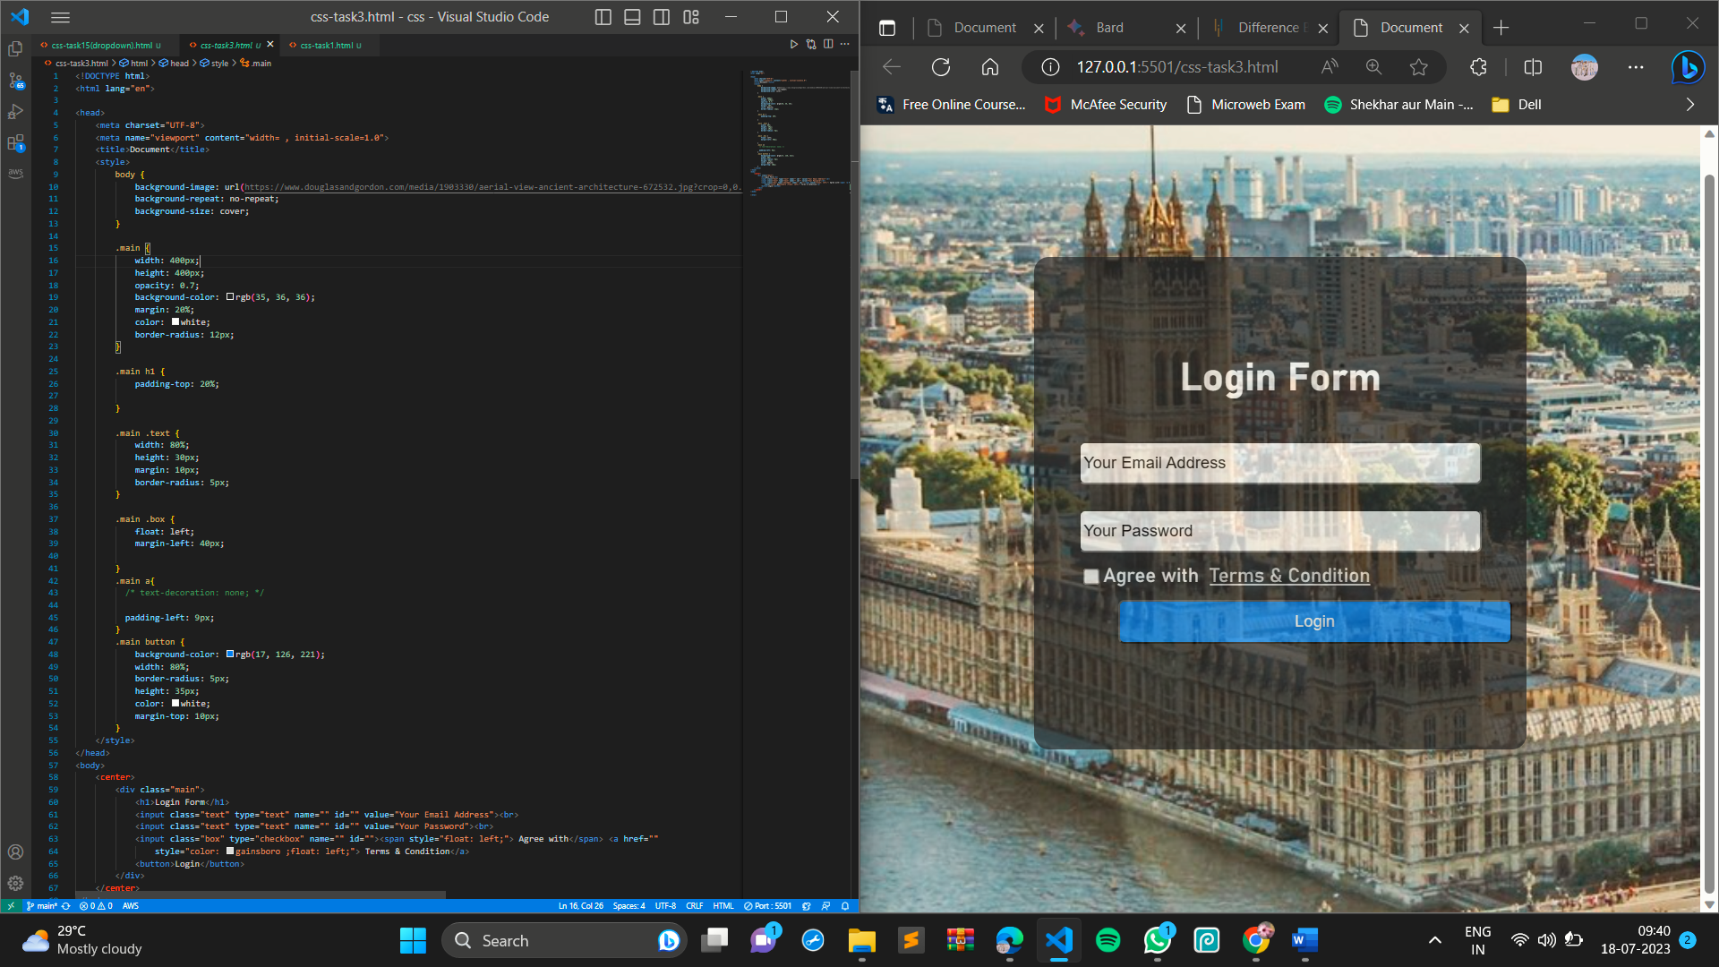

1. What is the use of the background-position property?

=> The background-position CSS property sets the position of a background image relative to its container. the bg-position property is used position of a background image set.

By default,the background is placed at the top-left corner of an elements, and both vertically and horizontally.

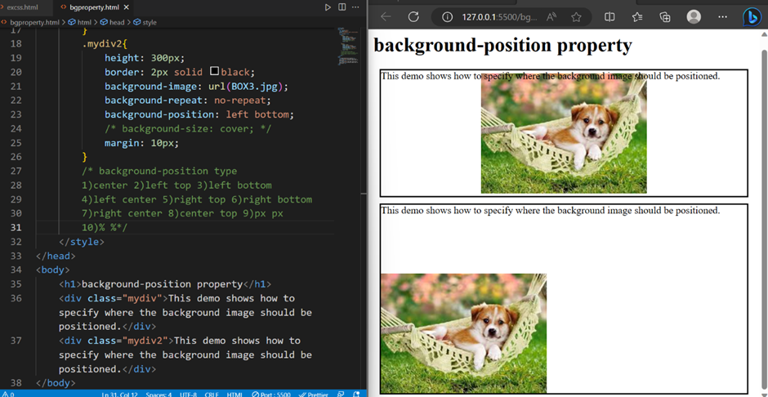

1. Which property controls the image scroll in the background?

=>

The background-attachment property in CSS controls whether a background image scrolls with the rest of the page, or is fixed in place.

scroll: The image will scroll with the rest of the page.

fixed: The image will be fixed in place, even when the page scrolls.

local: The image will scroll with the content of the element it is attached to.

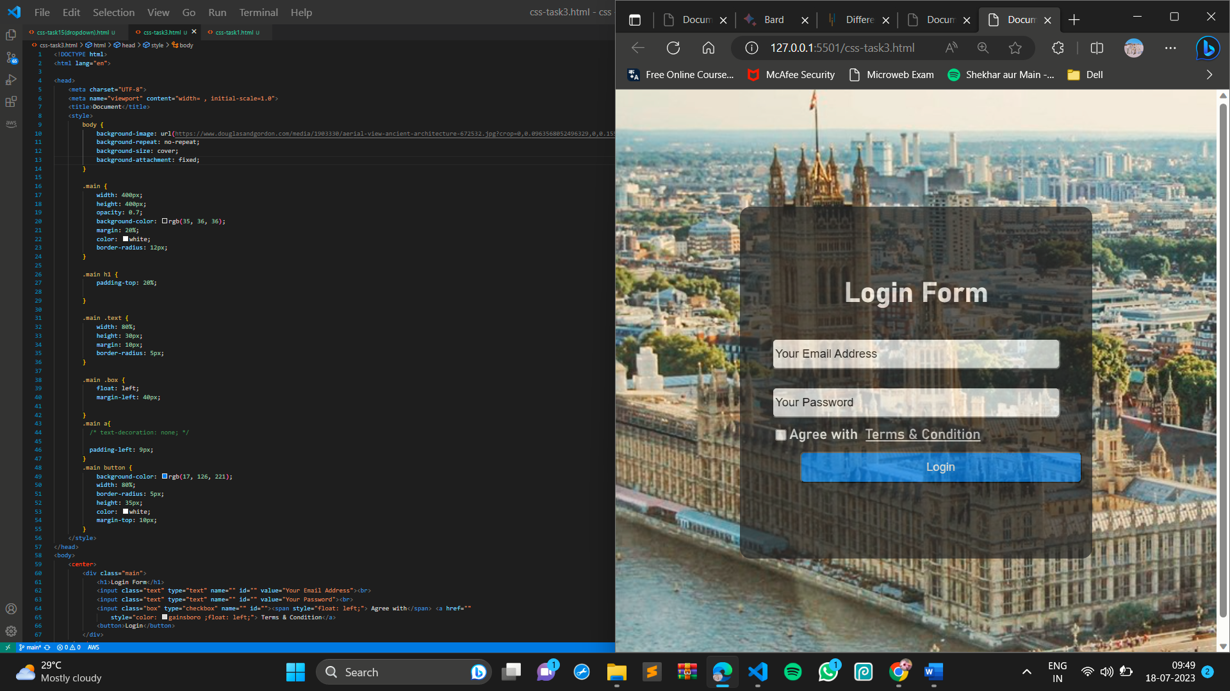

1. Why should background and color be used as separate properties?

=> The background and color properties in CSS are used to control the appearance of an element's background and text

div {

background-color: red;

color: blue;

}

This code would set the background color of the div element to red and the text color of the div element to blue. If the background and color properties were combined, the code would be more difficult to read and understand.

1. How to center block elements using CSS1?

=>

div {

margin: 0 auto;

text-align: center;

}

This code would set the margin-left and margin-right properties of the div element to auto, and the text-align property to center. This would tell the browser to center the div element within its container and center the text within the div element.

1. How to maintain the CSS specifications?

=>

The Cascading Style Sheets (CSS) specifications are maintained by the World Wide Web Consortium (W3C). The W3C is a standards organization that develops and maintains web standards.

The CSS specifications are maintained through a process of consensus building. This means that all interested parties, including browser vendors, web developers, and users, have a chance to contribute to the specifications.

The CSS specifications are divided into modules. Each module defines a specific aspect of CSS, such as layout, colors, or fonts. The modules are then combined to form the complete CSS specification.

The CSS specifications are updated on a regular basis

The CSS specifications are available online. You can find them at the W3C website.

1. What are the ways to integrate CSS as a web page?

=>

Internal CSS: This is the simplest way to integrate CSS. The CSS code is placed inside the style element in the head section of the HTML document.

External CSS: This is a more advanced way to integrate CSS. The CSS code is placed in a separate file, and the file is linked to the HTML document using the link element.

Inline CSS: This is the least common way to integrate CSS. The CSS code is placed inside the HTML element that it is styling.

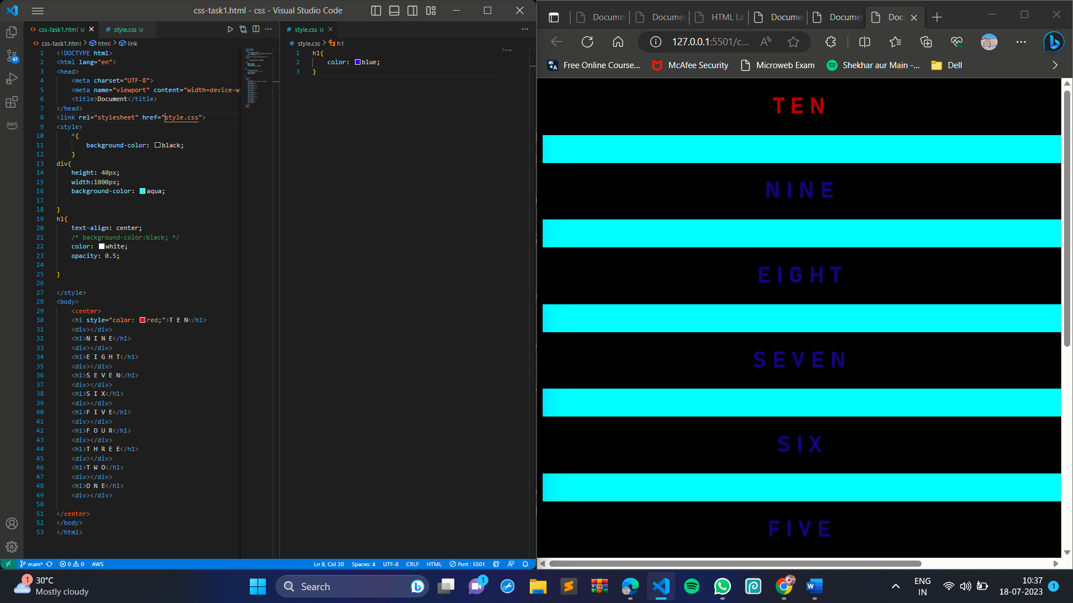

1. What is embedded style sheets?

=>

In CSS, an embedded style sheet is a style sheet that is defined within the HTML document itself. Embedded style sheets are typically used to style small web pages or to style parts of a web page.

Embedded style sheets are defined within the style element. The style element has the type attribute set to text/css. The style element contains the CSS code that is used to style the HTML document.

1. What are the external style sheets?

=>

An external style sheet is a separate file that contains CSS code. This code is then linked to your HTML document using the link element. External style sheets are a way of storing CSS code in a separate file from your HTML code.

Using link tag connect external css:-

<link rel="stylesheet" href="style.css">

1. What are the advantages and disadvantages of using external style sheets?

=>Advantages

Separation of concerns: External style sheets allow you to separate your CSS code from your HTML code.

Reusability: External style sheets can be reused across multiple HTML documents.

Performance: External style sheets can improve the performance of your web pages

Disadvantages

Increased file size: External style sheets can increase the file size of your web pages. This is because the CSS code is stored in a separate file.

Dependency: External style sheets make your web pages dependent on external files. This means that if the external style sheet is not available, your web pages will not display correctly.

1. What is the meaning of the CSS selector?

=>

In CSS, a selector is a rule that selects a specific element or group of elements. A selector is used to apply CSS styles to specific elements on a web page.

There are many different types of selectors, each of which selects elements in a different way. Some of the most common selectors include:

Element selectors: These selectors select elements by their tag name. For example, the selector h1 selects all h1 elements on a web page.

Class selectors: These selectors select elements by their class name. For example, the selector .my-class selects all elements with the class name my-class.

ID selectors: These selectors select elements by their ID. For example, the selector #my-id selects the element with the ID my-id.

Attribute selectors: These selectors select elements by their attributes. For example, the selector a[href] selects all anchor elements with the href attribute.

Pseudo-selectors: These selectors select elements based on their state or position. For example, the selector :hover selects all elements that are currently being hovered over.

Selectors can be combined to select more complex groups of elements. For example, the selector h1.my-class selects all h1 elements with the class name my-class.

1. What are the media types allowed by CSS?

=>

CSS supports a variety of media types, which allow you to style your web pages for different devices and environments. The following are some of the most common media types:

all: This media type applies to all devices and environments.

screen: This media type applies to screens, such as laptops and desktops.

print: This media type applies to printed pages.

speech: This media type applies to speech-based devices, such as screen readers.

handheld: This media type applies to handheld devices, such as smartphones and tablets.

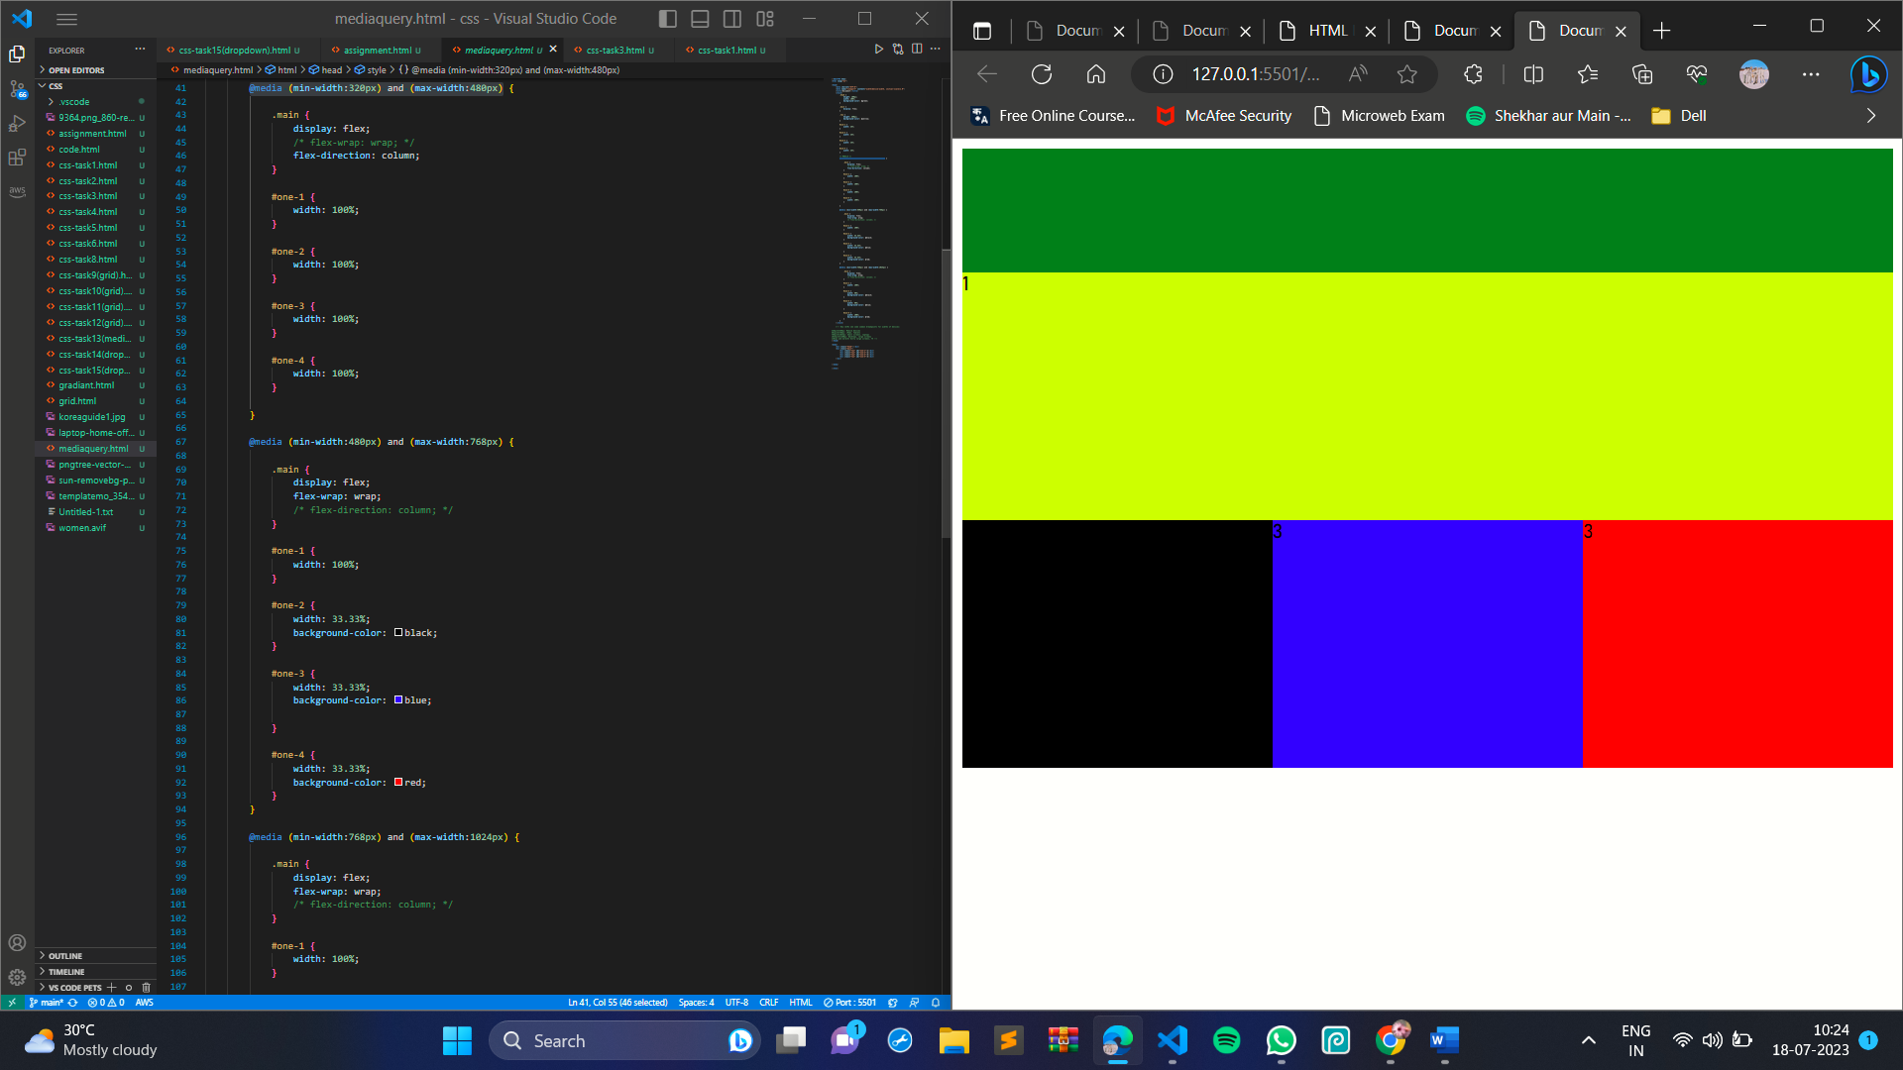

1. What is the rule set?

=> In CSS, a rule set is a group of declarations that are applied to a selector. A selector is a rule that selects a specific element or group of elements. A declaration is a rule that sets a property to a value.

For example, the following is a rule set that sets the font-size of all h1 elements to 24px:

CSS

h1 {

font-size: 24px;

}

The selector in this rule set is h1. This selector selects all h1 elements in the document. The declaration in this rule set is font-size: 24px. This declaration sets the font-size property of all h1 elements to 24px.

1. Create Layouts

